Hide "Powered By Odoo"

<https://youtu.be/QJGqQzxsohY?feature=shared>

[Website analytics — Odoo 17.0 documentation](https://www.odoo.com/documentation/17.0/applications/websites/website/reporting/analytics.html)

<https://www.odoo.com/documentation/17.0/applications/websites/website/reporting/analytics.html>

<https://plausible.io/register>

trenders.intl@gmail.com

Trend@PLBL2024

Google

<!-- Google tag (gtag.js) --> <script async src="https://www.googletagmanager.com/gtag/js?id=G-L979M2DYMC"></script> <script> window.dataLayer = window.dataLayer || []; function gtag(){dataLayer.push(arguments);} gtag('js', new Date()); gtag('config', 'G-L979M2DYMC'); </script>

<https://www.odoo.com/documentation/17.0/applications/websites/website/configuration/google_search_console.html?highlight=google%20search>

<https://search.google.com/search-console?resource_id=https%3A%2F%2Ftrend-ai.net%2F>

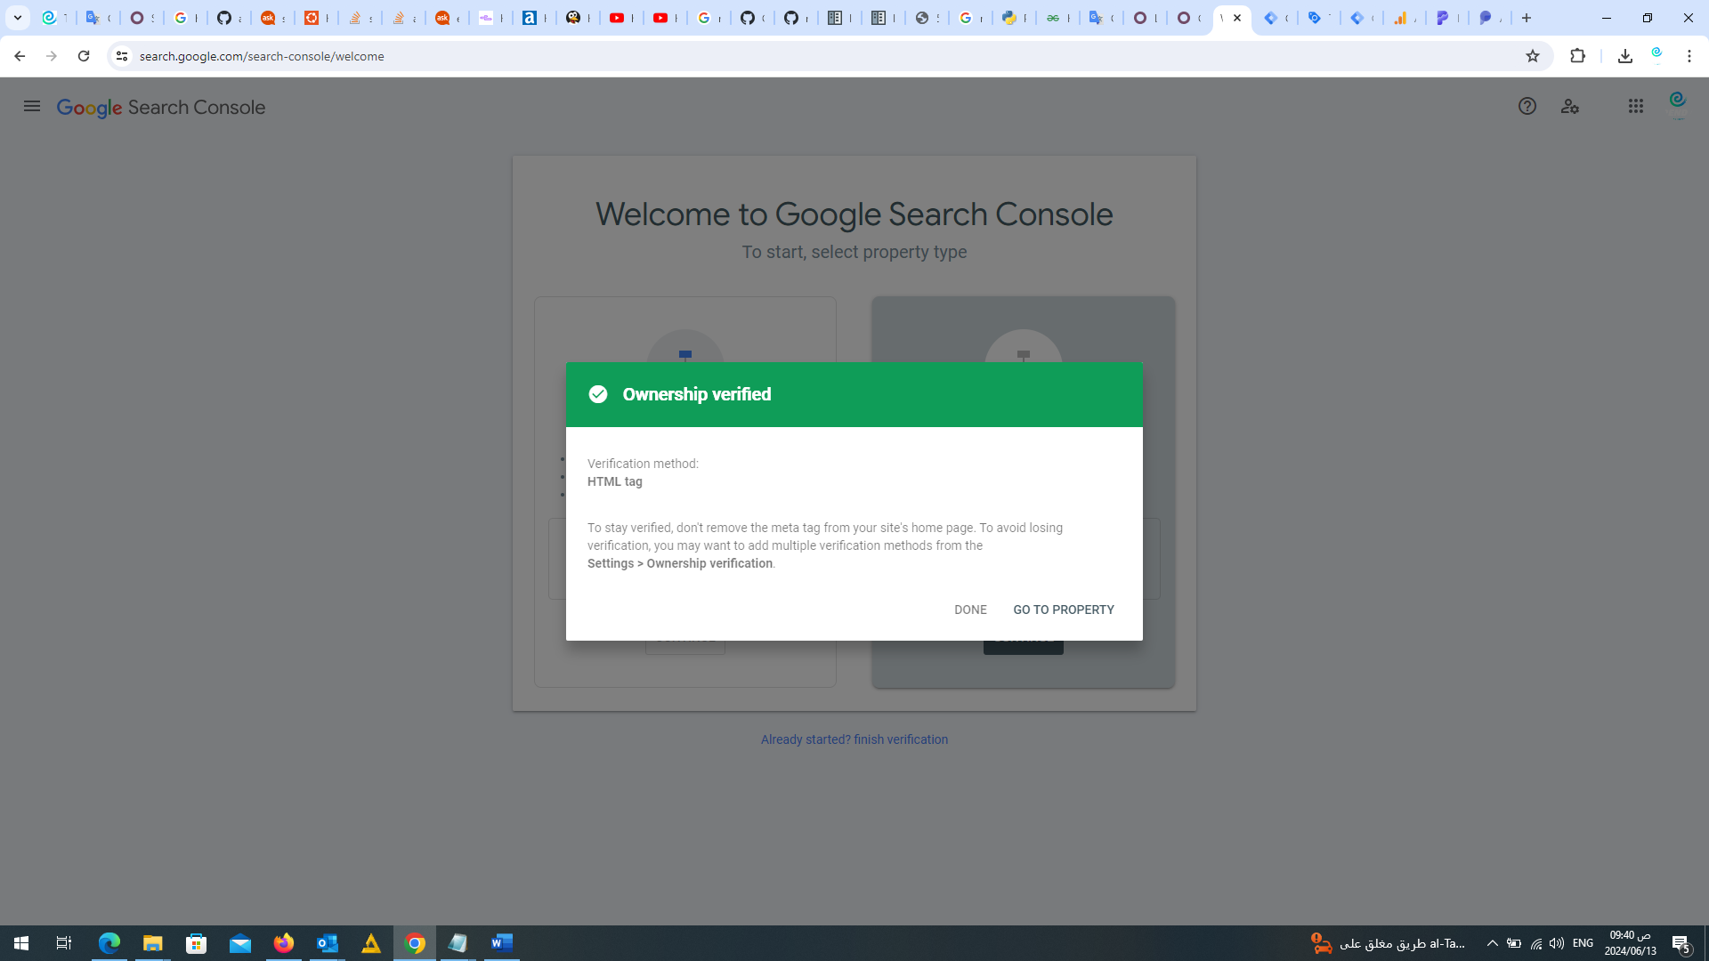

<https://search.google.com/search-console?resource_id=https%3A%2F%2Ftrend-ai.net%2F>